Client Demo

Add a menu line

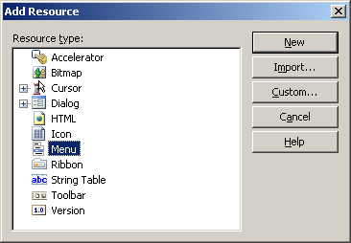

Click new.

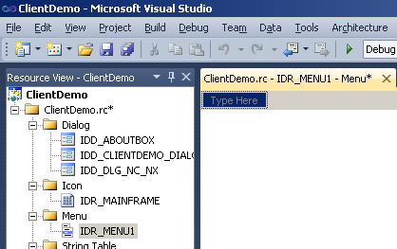

Added top line File and SetUp items. The under Setup added NcNx

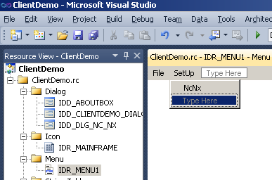

Double click NcNx and get properties shown.

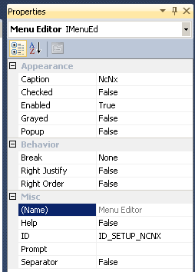

Right click NcNx menu item (VS 2010 )

Add IDR_MENU1 to the properties of ClientDemoDlg.

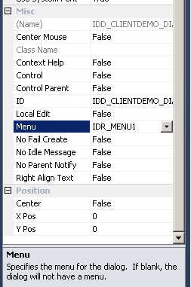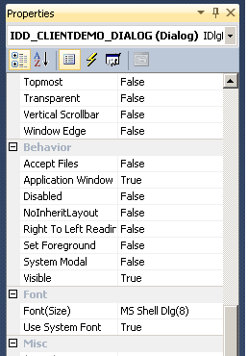

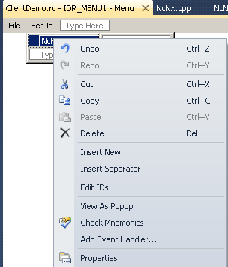

Select Add Event Handler

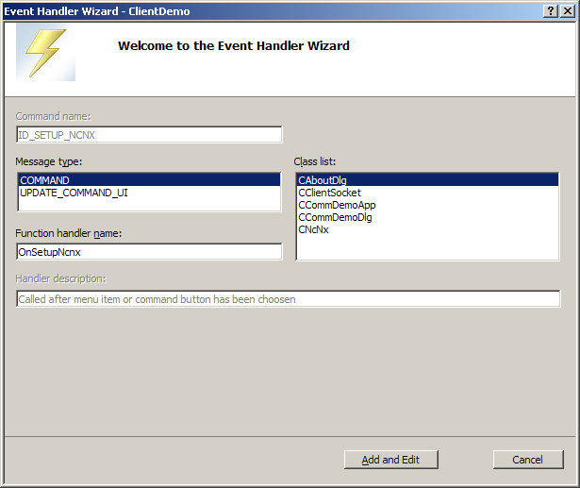

Select the main dialog as the class to get the event handler.

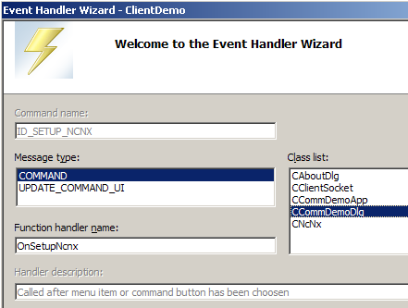

This inserts the following code:

void CCommDemoDlg::OnSetupNcnx()

{

// TODO: Add your command handler code here

}

Define a global structure in global.h to hold pointers to modeless dialogs and the main dialog.

/*

Define global dialog ptrs.

*/

#include "ClientDemoDlg.h"

#include "NcNx.h"

typedef struct

{

CCommDemoDlg *pUIDlg; // the user interface dialog

CNcNx *pNcNx;

} GLOBAL_DLG_PTRS;

#ifdef MAIN_MODULE

#define PUBEXT

#else

#define PUBEXT extern

#endif

PUBEXT GLOBAL_DLG_PTRS gDlg;

Define a header called MainModuleGlobal.h to govern the definition of MAIN_MODULE

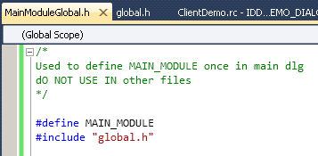

Include MainModuleGlobal.h only in the main dialog.

